Mariam Mohamed Bahaa 6401

Yara Tarek Fathy 6445

Nour Mohamed Gaber 6392

Nada Ossama Soffar 6503

Sara Tarek Awny 6475

Hania Mohamed Abo Elamayem 6257

Final Project Report

**EXPERIMENT ONE: DOUBLE SIDEBAND MODULATION**

**Signal in time and frequency domains:**

%Plotting of original signal in TIME domain

t = linspace(0, length(y)/fs, length(y));

figure();

subplot(2,1,1);

plot(t,y);

title('Signal in time domain');

xlabel('Time');

ylabel('Amplitude');

%Plotting of original signal in FREQUENCY domain

yf = fftshift(fft(y));

f = linspace(-fs/2, fs/2, length(yf));

subplot(2,1,2);

plot(f, abs(yf)./fs);

title('Signal in frequency domain');

xlabel('Frequency');

ylabel('Amplitude');

Filter in frequency domain:

%filter

filter_freq = 4000;

lp = ones(length(yf),1);

lp(abs(f)>filter_freq) = 0;

yf_filtered = (lp.*yf);

%plot the filter

f2 = linspace(-fs/2,fs/2,length(lp));

figure();

plot(f2,abs(lp)./fs);

title('Filter');

xlabel('Frequency');

ylabel('Amplitude');

Signal after filter:

%plot the filtered signal

f2 = linspace(-fs/2,fs/2,length(yf_filtered));

figure();

subplot(2,1,2);

plot(f2,abs(yf_filtered)./fs);

title('Filtered Signal in frequency domain');

xlabel('Frequency');

ylabel('Amplitude');

yt_filtered = ifft(ifftshift(yf_filtered));

subplot(2,1,1);

plot(t,real(yt_filtered));

title('Filtered Signal in time domain');

xlabel('Time');

ylabel('Amplitude');

%sound(real(yt_filtered), fs);

Signal after DSBSC modulation:

%DSBSC mod

fc=100000;

fs_new=5*fc;

yt_new = resample(yt_filtered,fs_new,fs);

t_new=linspace(0, length(yt_new)/fs_new, length(yt_new));

carrier=transpose(cos(2*pi*fc*t_new));

yt_dsbsc=yt_new.*carrier;

yf_dsbsc=real(fftshift(fft(yt_dsbsc)));

f_new=linspace(-fs_new/2,fs_new/2,length(yt_dsbsc));

%plot

figure();

subplot(2,1,1);

plot(t_new,real(yt_dsbsc));

title('DSBSC modulated Signal in time domain');

xlabel('Time');

ylabel('Amplitude');

subplot(2,1,2);

plot(f_new,abs(yf_dsbsc)./fs_new);

title('DSBSC modulated Signal in frequency domain');

xlabel('Frequency');

ylabel('Amplitude');

DSBSC after envelope demodulation:

%DSBSC env demod

yt_sc_env = resample(abs(hilbert(real(yt_dsbsc))),fs,fs_new);

yf_sc_env = real(fftshift(fft(yt_sc_env)));

%plot

figure();

subplot(2,1,1);

t1=linspace(0,length(yt_sc_env)/fs,length(yt_sc_env));

plot(t1,real(yt_sc_env));

title('DSBSC envelope demodulated Signal in time domain');

xlabel('Time');

ylabel('Amplitude');

subplot(2,1,2);

f1 = linspace(-fs/2, fs/2, length(yf_sc_env));

plot(f1,abs(yf_sc_env)./fs);

title('DSBSC envelope demodulated Signal in frequency domain');

xlabel('Frequency');

ylabel('Amplitude');

%sound(real(yt_sc_env),fs); %sound of DSBSC env demod

DSBSC after coherent detection with no SNR:

%DSBSC coherent demodulation and SNR

t_coh=linspace(0,length(yt_dsbsc)/fs_new,length(yt_dsbsc));

carrier_coh_no_snr=transpose(cos(2*pi*fc*t_coh));

yt_sc_coh=yt_dsbsc.*carrier_coh_no_snr;

yf_sc_coh=fftshift(fft(yt_sc_coh));

lp_sc_coh= 2*ones(length(yt_dsbsc),1);

lp_sc_coh(abs(f)>4000) = 0;

yf_sc_no_snr_filtered = lp_sc_coh.*yf_sc_coh;

temp_after_filter=ifft(ifftshift(yf_sc_no_snr_filtered));

yt_sc_coh_no_snr=resample(temp_after_filter,fs,fs_new);

yf_sc_coh_no_snr=real(fftshift(fft(yt_sc_coh_no_snr)));

%plot

figure();

subplot(2,1,1);

t_after_resample=linspace(0,length(yt_sc_coh_no_snr)/fs,length(yt_sc_coh_no_snr));

plot(t_after_resample,real(yt_sc_coh_no_snr));

title('DSBSC coherent demodulated Signal no snr in time domain');

xlabel('Time');

ylabel('Amplitude');

subplot(2,1,2);

f_after_resample=linspace(-fs/2,fs/2,length(yf_sc_coh_no_snr));

plot(f_after_resample,abs(yf_sc_coh_no_snr)./fs);

title('DSBSC coherent demodulated Signal no snr in frequency domain');

xlabel('Frequency');

ylabel('Amplitude');

%sound(real(yt_sc_coh_no_snr),fs);

DSBSC after coherent detection with SNR=0:

%SNR=0

yt_coh_0_snr=awgn(yt_dsbsc,0);

t_coh=linspace(0,length(yt_coh_0_snr)/fs_new,length(yt_coh_0_snr));

carrier_coh_0_snr=transpose(cos(2*pi*fc*t_coh));

temp_before_filter=yt_coh_0_snr.*carrier_coh_0_snr;

yf_coh_0_snr=fftshift(fft(temp_before_filter));

f_SNR0=linspace(-(fs_new)/2,(fs_new)/2,length(yf_coh_0_snr));

lp_sc_coh= 2*ones(length(yt_coh_0_snr),1);

lp_sc_coh(abs(f_SNR0)>4000) = 0;

yf_sc_0_snr_filtered = lp_sc_coh.*yf_coh_0_snr;

temp_after_filter=ifft(ifftshift(yf_sc_0_snr_filtered));

yt_sc_coh_0_snr=resample(temp_after_filter,fs,fs_new);

yf_sc_coh_0_snr=real(fftshift(fft(yt_sc_coh_0_snr)));

%plot

figure();

subplot(2,1,1);

t_after_resample=linspace(0,length(yt_sc_coh_0_snr)/fs,length(yt_sc_coh_0_snr));

plot(t_after_resample,real(yt_sc_coh_0_snr));

title('DSBSC coherent demodulated Signal SNR=0 in time domain');

xlabel('Time');

ylabel('Amplitude');

subplot(2,1,2);

f_after_resample=linspace(-fs/2,fs/2,length(yf_sc_coh_0_snr));

plot(f_after_resample,abs(yf_sc_coh_0_snr)./fs);

title('DSBSC coherent demodulated Signal SNR=0 in frequency domain');

xlabel('Frequency');

ylabel('Amplitude');

%sound(real(yt_sc_coh_0_snr),fs);

DSBSC after coherent detection with SNR=10:

%SNR=10

yt_coh_10_snr=awgn(yt_dsbsc,10);

t_coh=linspace(0,length(yt_coh_10_snr)/fs_new,length(yt_coh_10_snr));

carrier_coh_10_snr=transpose(cos(2*pi*fc*t_coh));

temp_before_filter=yt_coh_10_snr.*carrier_coh_10_snr;

yf_coh_10_snr=fftshift(fft(temp_before_filter));

f_SNR10=linspace(-(fs_new)/2,(fs_new)/2,length(yf_coh_10_snr));

lp_sc_coh= 2*ones(length(yt_coh_10_snr),1);

lp_sc_coh(abs(f_SNR10)>4000) = 0;

yf_sc_10_snr_filtered = lp_sc_coh.*yf_coh_10_snr;

temp_after_filter=ifft(ifftshift(yf_sc_10_snr_filtered));

yt_sc_coh_10_snr=resample(temp_after_filter,fs,fs_new);

yf_sc_coh_10_snr=real(fftshift(fft(yt_sc_coh_10_snr)));

%plot

figure();

subplot(2,1,1);

t_after_resample=linspace(0,length(yt_sc_coh_10_snr)/fs,length(yt_sc_coh_10_snr));

plot(t_after_resample,real(yt_sc_coh_10_snr));

title('DSBSC coherent demodulated Signal SNR=10 in time domain');

xlabel('Time');

ylabel('Amplitude');

subplot(2,1,2);

f_after_resample=linspace(-fs/2,fs/2,length(yf_sc_coh_10_snr));

plot(f_after_resample,abs(yf_sc_coh_10_snr)./fs);

title('DSBSC coherent demodulated Signal SNR=10 in frequency domain');

xlabel('Frequency');

ylabel('Amplitude');

%sound(real(yt_sc_coh_10_snr),fs);

DSBSC after coherent detection with SNR=30:

%SNR=30

yt_coh_30_snr=awgn(yt_dsbsc,30);

t_coh=linspace(0,length(yt_coh_30_snr)/fs_new,length(yt_coh_30_snr));

carrier_coh_30_snr=transpose(cos(2*pi*fc*t_coh));

temp_before_filter=yt_coh_30_snr.*carrier_coh_30_snr;

yf_coh_30_snr=fftshift(fft(temp_before_filter));

f_SNR30=linspace(-(fs_new)/2,(fs_new)/2,length(yf_coh_30_snr));

lp_sc_coh= 2*ones(length(yt_coh_30_snr),1);

lp_sc_coh(abs(f_SNR30)>4000) = 0;

yf_sc_30_snr_filtered = lp_sc_coh.*yf_coh_30_snr;

temp_after_filter=ifft(ifftshift(yf_sc_30_snr_filtered));

yt_sc_coh_30_snr=resample(temp_after_filter,fs,fs_new);

yf_sc_coh_30_snr=real(fftshift(fft(yt_sc_coh_30_snr)));

%plot

figure();

subplot(2,1,1);

t_after_resample=linspace(0,length(yt_sc_coh_30_snr)/fs,length(yt_sc_coh_30_snr));

plot(t_after_resample,real(yt_sc_coh_30_snr));

title('DSBSC coherent demodulated Signal SNR=30 in time domain');

xlabel('Time');

ylabel('Amplitude');

subplot(2,1,2);

f_after_resample=linspace(-fs/2,fs/2,length(yf_sc_coh_30_snr));

plot(f_after_resample,abs(yf_sc_coh_30_snr)./fs);

title('DSBSC coherent demodulated Signal SNR=30 in frequency domain');

xlabel('Frequency');

ylabel('Amplitude');

%sound(real(yt_sc_coh_30_snr),fs);

DSBSC coherent detection with phase error:

%phase error

t_coh=linspace(0,length(yt_dsbsc)/fs_new,length(yt_dsbsc));

carrier_coh_phase_error=transpose(cos(2*pi*fc*t_coh+(20*(pi/180))));

temp_before_filter=yt_dsbsc.*carrier_coh_phase_error;

yf_sc_coh_phase_error=fftshift(fft(temp_before_filter));

lp_sc_coh= 2*ones(length(yt_dsbsc),1);

lp_sc_coh(abs(f)>fs_new) = 0;

yf_sc_phase_error_filtered = lp_sc_coh.*yf_sc_coh_phase_error;

temp_after_filter=ifft(ifftshift(yf_sc_phase_error_filtered));

yt_sc_coh_phase_error=resample(temp_after_filter,fs,fs_new);

yf_sc_coh_phase_error=real(fftshift(fft(yt_sc_coh_phase_error)));

%plot

figure();

subplot(2,1,1);

t_after_resample=linspace(0,length(yt_sc_coh_phase_error)/fs,length(yt_sc_coh_phase_error));

plot(t_after_resample,real(yt_sc_coh_phase_error));

title('DSBSC coherent demodulated Signal phase error in time domain');

xlabel('Time');

ylabel('Amplitude');

subplot(2,1,2);

f_after_resample=linspace(-fs/2,fs/2,length(yf_sc_coh_phase_error));

plot(f_after_resample,abs(yf_sc_coh_phase_error)./fs);

title('DSBSC coherent demodulated Signal phase error in frequency domain');

xlabel('Frequency');

ylabel('Amplitude');

% sound(real(yt_sc_coh_phase_error),fs);

DSBSC coherent detection with frequency error:

%frequency error

t_coh=linspace(0,length(yt_dsbsc)/fs_new,length(yt_dsbsc));

carrier_coh_freq_error=transpose(cos(2*pi*100100*t_coh));

temp_before_filter=yt_dsbsc.*carrier_coh_freq_error;

yf_sc_coh_freq_error=fftshift(fft(temp_before_filter));

lp_sc_coh= 2*ones(length(yt_dsbsc),1);

lp_sc_coh(abs(f)>fs_new) = 0;

yf_sc_freq_error_filtered = lp_sc_coh.*yf_sc_coh_freq_error;

temp_after_filter=ifft(ifftshift(yf_sc_freq_error_filtered));

yt_sc_coh_freq_error=resample(temp_after_filter,fs,fs_new);

yf_sc_coh_freq_error=real(fftshift(fft(yt_sc_coh_freq_error)));

%plot

figure();

subplot(2,1,1);

t_after_resample=linspace(0,length(yt_sc_coh_freq_error)/fs,length(yt_sc_coh_freq_error));

plot(t_after_resample,real(yt_sc_coh_freq_error));

title('DSBSC coherent demodulated Signal frequency error in time domain');

xlabel('Time');

ylabel('Amplitude');

subplot(2,1,2);

f_after_resample=linspace(-fs/2,fs/2,length(yf_sc_coh_freq_error));

plot(f_after_resample,abs(yf_sc_coh_freq_error)./fs);

title('DSBSC coherent demodulated Signal frquency error in frequency domain');

xlabel('Frequency');

ylabel('Amplitude');

%sound(real(yt_sc_coh_freq_error),fs);

DSBTC modulated signal:

%DSBTC mod

Am=max(abs(real(yt_new))); %max gain of message

yt_dsbtc=(2*Am+real(yt_new)).*carrier;

yf_dsbtc=real(fftshift(fft(yt_dsbtc)));

%plot

figure();

subplot(2,1,1);

plot(t_new,real(yt_dsbtc));

title('DSBTC modulated Signal in time domain');

xlabel('Time');

ylabel('Amplitude');

subplot(2,1,2);

plot(f_new,abs(yf_dsbtc));

xlim([-10500 10500])

title('DSBTC modulated Signal in frequency domain');

xlabel('Frequency');

ylabel('Amplitude');

DSBTC envelope demodulated signal:

%DSBTC envelope demodulation

yt_tc_env = resample(abs(hilbert((yt_dsbtc))),fs,fs_new)-(2*Am);

yf_tc_env = real(fftshift(fft(yt_tc_env)));

%plot

figure();

subplot(2,1,1);

t1=linspace(0,length(yt_tc_env)/fs,length(yt_tc_env));

plot(t1,yt_tc_env);

title('DSBTC envelope demod Signal in time domain');

xlabel('Time');

ylabel('Amplitude');

subplot(2,1,2);

f1 = linspace(-fs/2, fs/2, length(yf_tc_env));

plot(f1,abs(yf_tc_env)./fs);

title('DSBTC envelope demod Signal in frequency domain');

xlabel('Frequency');

ylabel('Amplitude');

%sound(real(yt_tc_env),fs);

**Comments**:

DSBTC envelope modulated sound is so much better and clearer than DSBSC envelope demodulated, therefore envelope modulation should be used with DSBTC.

Adding the frequency causes error of 100Hz

Vx(t)= Ac m(t) cos(2fct) cos(2π(fc+f)t)

= (Ac m(t) )/2 [ cos(2π(2fc+f)t) +cos(2πft)] f<<<

= (Ac m(t) )/2 cos(2πft)

f must =0, else it is distorted

**EXPERIMENT TWO: SINGLE SIDEBAND MODULATION**

**%(5)Obtain the SSB by filtering out the USB (we need to get LSB only) of the DSB-SC modulated**

**%signal using an ideal filter then Plot the spectrum again.**

f_ssb=linspace(-(fs_new/2),(fs_new/2),length(yf_dsbsc));

lpfc = 2.*ones(length(yf_dsbsc),1);

lpfc(abs(f_ssb)>fc) = 0;

yf_lssb = lpfc.*yf_dsbsc;

yt_ssb = ifft(ifftshift(yf_lssb));

t_ssb=linspace(0, length(yt_ssb)/fs_new, length(yt_ssb));

figure();

subplot(2,1,1);

plot(f_ssb,abs(yf_lssb)./fs_new);

title('Single SideBand Modulation (LSB) frequency domain');

xlabel('Frequency');

ylabel('Amplitude');

subplot(2,1,2);

plot(t_ssb,real(yt_ssb));

title('Single SideBand Modulation (LSB) time domain');

xlabel('Time');

ylabel('Amplitude');

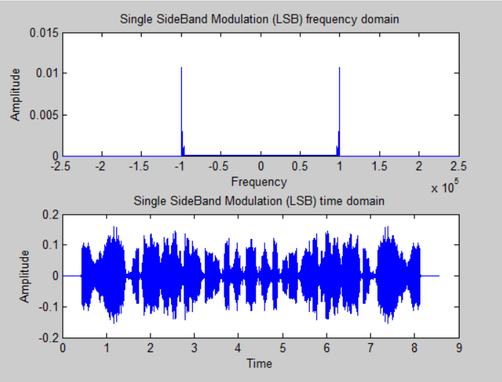

**%(6)-Use coherent detection with no noise interference to get the received signal (to demodulate the**

**%SSB-SC) and play the file back also sketch the received waveform and spectrum**

**%SSB coherent demod time domain**

carrier1=cos(2*pi*fc*t_ssb).';

yt_ssbdemod = carrier1.*yt_ssb;

**%SSB coherent demod freq domain**

yf_ssbdemod = fftshift(fft(yt_ssbdemod));

**%filter ssb**

yf_ssbdemod(f_ssb>4000) = 0;

yf_ssbdemod(f_ssb<-4000) = 0;

yf_ssbdemod2 = yf_ssbdemod.*2;

**%filtered ssb demodulated**

f_ssbf=linspace(-(fs_new/2),(fs_new/2),length(yf_ssbdemod2));

yt_ssbdemodf = ifft(ifftshift(yf_ssbdemod2));

yt_ssbdemodf = resample(yt_ssbdemodf,fs,fs_new);

t_ssbf=linspace(0, length(yt_ssbdemodf)/fs_new, length(yt_ssbdemodf));

figure();

subplot(2,1,1);

plot(f_ssbf,abs(yf_ssbdemod2)./fs);

title('SSB cohDemodulated (Frequency)');

xlabel('Frequency');

ylabel('Amplitude');

subplot(2,1,2);

plot(t_ssbf,real(yt_ssbdemodf));

title('SSB cohDemodulated (Time)');

xlabel('Time');

ylabel('Amplitude');

%sound(real(yt_ssbdemodf),fs);

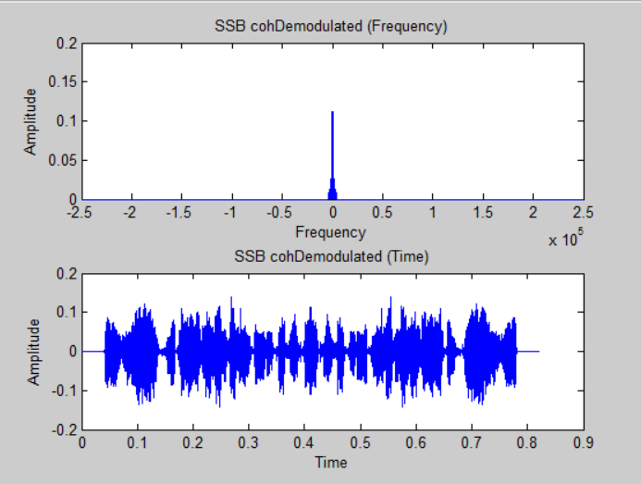

**%(7)Repeat steps 5 and 6, only this time. Use a practical 4th order Butterworth filter.**

**%ssb butterworth**

flow=(fc-4e3)/(fs_new/2);

fhigh=fc/(fs_new/2);

fcut=[flow,fhigh];

[a,b] = butter(4,fcut);

yt_ssb2 = filter(a,b,yt_dsbsc).*2;

yf_ssb2 = fftshift(fft(yt_ssb2));

f_ssb2=linspace(-(fs_new/2),(fs_new/2),length(yf_ssb2));

t_ssb2 = linspace(0, length(yt_ssb2)/fs_new, length(yt_ssb2));

figure();

subplot(2,1,1);

plot(f_ssb2,abs(yf_ssb2)./fs_new);

title('Single SideBand butter (frequency)');

xlabel('Frequency');

ylabel('Amplitude');

subplot(2,1,2);

plot(t_ssb2,real(yt_ssb2));

title('Single SideBand butter (time)');

xlabel('Time');

ylabel('Amplitude');

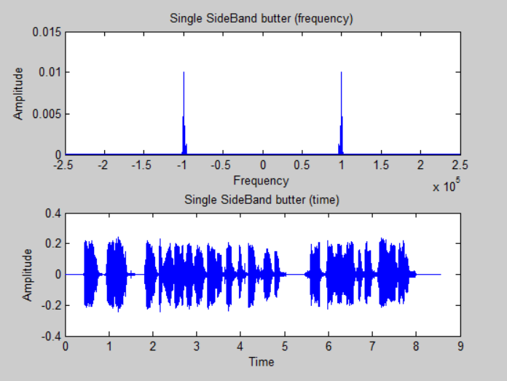

**%ssb butter cohdemodulation**

carrier5=cos(2*pi*fc*t_ssb2).';

yt_ssbbutterdemod = carrier5.*yt_ssb2;

**%SSB cohbutter demod freq domain**

yf_ssbbutterdemod = fftshift(fft(yt_ssbbutterdemod));

**%filter ssb**

filter_freq = 4000;

lp4 = 2.*ones(length(yf_ssbbutterdemod),1);

lp4(abs(f_ssb2)>filter_freq) = 0;

**%filtered ssb demodulated**

yf_ssbbutterdemodf = lp4.*yf_ssbbutterdemod;

f_ssbbutterf=linspace(-(fs_new/2),(fs_new/2),length(yf_ssbbutterdemodf));

yt_ssbbutterdemodf = ifft(ifftshift(yf_ssbbutterdemodf));

yt_ssbbutterdemodf = resample(yt_ssbbutterdemodf,fs,fs_new);

t_ssbbutterf = linspace(0, length(yt_ssbbutterdemodf)/fs_new, length(yt_ssbbutterdemodf));

figure();

subplot(2,1,1);

plot(f_ssbbutterf,abs(yf_ssbbutterdemodf)./fs);

title('SSB butter cohdemod(frequency)');

xlabel('Frequency');

ylabel('ssb');

subplot(2,1,2);

plot(t_ssbbutterf,real(yt_ssbbutterdemodf));

title('SSB butter cohdemod(time)');

xlabel('Time');

ylabel('ssb');

%sound(real(yt_ssbbutterdemodf),fs);

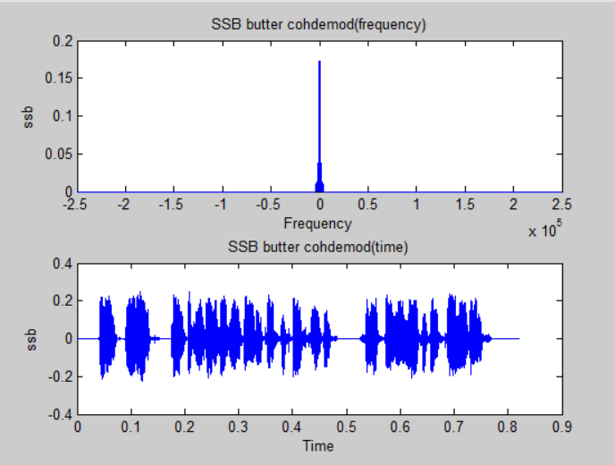

**%(8) For the ideal filter case, get the received signal again but when noise is added to SSB-SC with**

**%SNR = 0, 10, and 30 also play the received sound and sketch the received waveform/spectrum in**

**%each case.**

**%SNR 0**

yt_SNR0 = awgn(yt_ssb, 0);

t_SNR0=linspace(0, length(yt_SNR0)/fs_new, length(yt_SNR0));

carrier2=cos(2*pi*fc*t_SNR0).';

yt_SNR0demod = carrier2.*yt_SNR0;

yf_SNR0demod = fftshift(fft(yt_SNR0demod));

f_SNR0=linspace(-(fs_new/2),(fs_new/2),length(yf_SNR0demod));

**%LPF SNR0**

filter_freq = 4000;

lp3 = 2.*ones(length(yf_SNR0demod),1);

lp3(abs(f_SNR0)>filter_freq) = 0;

**%filtered ssb demodulated**

yf_SNR0demodf = lp3.*yf_SNR0demod;

f_SNR0f=linspace(-(fs_new/2),(fs_new/2),length(yf_SNR0demodf));

yt_SNR0demodf= ifft(ifftshift(yf_SNR0demodf));

yt_SNR0demodf = resample(yt_SNR0demodf,fs,fs_new);

t_SNR0f=linspace(0, length(yt_SNR0demodf)/fs_new, length(yt_SNR0demodf));

figure();

subplot(2,1,1);

plot(f_SNR0f,abs(yf_SNR0demodf)./fs);

title('Single SideBand SNR0 demod (frequency)');

xlabel('Frequency');

ylabel('ssb');

subplot(2,1,2);

plot(t_SNR0f,real(yt_SNR0demodf));

title('Single SideBand SNR0 demod (time)');

xlabel('Time');

ylabel('ssb');

%sound(real(yt_SNR0demodf),fs);

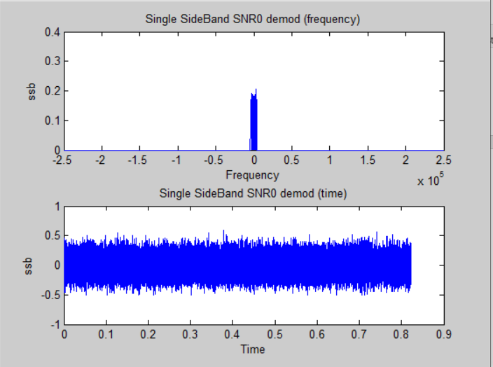

**%SNR 10**

yt_SNR10 = awgn(yt_ssb, 10);

t_SNR10=linspace(0, length(yt_SNR10)/fs_new, length(yt_SNR10));

carrier3=cos(2*pi*fc*t_SNR10).';

yt_SNR10demod = carrier3.*yt_SNR10;

yf_SNR10demod = fftshift(fft(yt_SNR10demod));

f_SNR10=linspace(-(fs_new/2),(fs_new/2),length(yf_SNR10demod));

**%lpf**

filter_freq = 4000;

lp10 = 2.*ones(length(yf_SNR10demod),1);

lp10(abs(f_SNR10)>filter_freq) = 0;

**%filtered ssb demodulated**

yf_SNR10demodf = lp10.*yf_SNR10demod;

yt_SNR10demodf= ifft(ifftshift(yf_SNR10demodf));

f_SNR10f=linspace(-(fs_new/2),(fs_new/2),length(yf_SNR10demodf));

yt_SNR10demodf = resample(yt_SNR10demodf,fs,fs_new);

t_SNR10f=linspace(0, length(yt_SNR10demodf)/fs_new, length(yt_SNR10demodf));

figure();

subplot(2,1,1);

plot(f_SNR10f,abs(yf_SNR10demodf)./fs);

title('Single SideBand SNR10 demod (frequency)');

xlabel('Frequency');

ylabel('ssb');

subplot(2,1,2);

plot(t_SNR10f,real(yt_SNR10demodf));

title('Single SideBand SNR10 demod (time)');

xlabel('Time');

ylabel('ssb');

%sound(real(yt_SNR10demodf),fs);

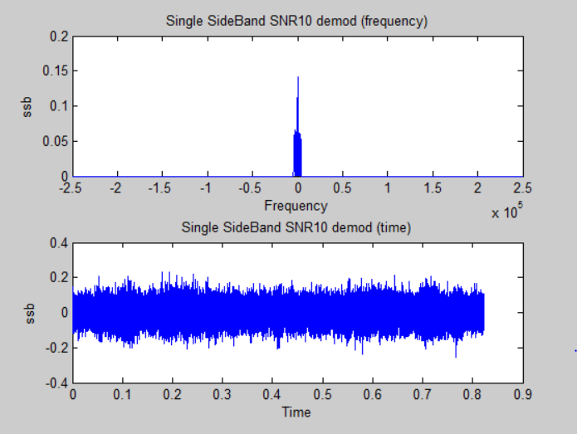

**%SNR 30**

yt_SNR30 = awgn(yt_ssb, 30);

t_SNR30=linspace(0, length(yt_SNR30)/fs_new, length(yt_SNR30));

carrier4=cos(2*pi*fc*t_SNR30).';

yt_SNR30demod = carrier3.*yt_SNR30;

yf_SNR30demod = fftshift(fft(yt_SNR30demod));

f_SNR30=linspace(-(fs_new/2),(fs_new/2),length(yf_SNR30demod));

**%LPF SNR30**

filter_freq = 4000;

lp30 = 2.*ones(length(yf_SNR30demod),1);

lp30(abs(f_SNR30)>filter_freq) = 0;

%filtered ssb demodulated

yf_SNR30demodf = lp30.*yf_SNR30demod;

yt_SNR30demodf = ifft(ifftshift(yf_SNR30demodf));

f_SNR30f=linspace(-(fs_new/2),(fs_new/2),length(yf_SNR30demodf));

yt_SNR30demodf = resample(yt_SNR30demodf,fs,fs_new);

t_SNR30f=linspace(0, length(yt_SNR30demodf)/fs_new, length(yt_SNR30demodf));

figure();

subplot(2,1,1);

plot(f_SNR30f,abs(yf_SNR30demodf)./fs_new);

title('Single SideBand SNR30 demod (frequency)');

xlabel('Frequency');

ylabel('ssb');

subplot(2,1,2);

plot(t_SNR30f,yt_SNR30demodf);

title('Single SideBand SNR30 demod (time)');

xlabel('Time');

ylabel('ssb');

%sound(real(yt_SNR30demodf),fs);

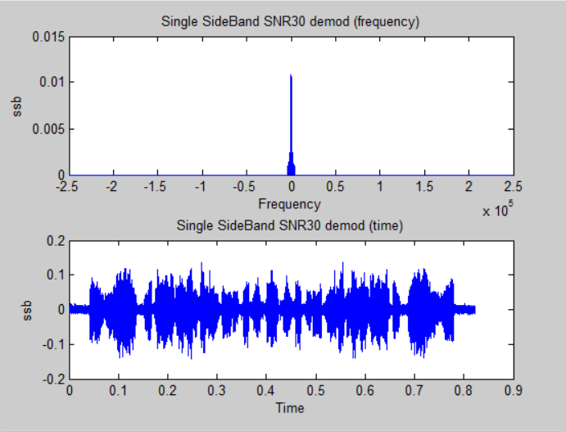

**%SSB-TC**

f_ssbtc=linspace(-(fs_new/2),(fs_new/2),length(yf_dsbtc));

yf_dsbtc(f_ssbtc>100001) = 0;

yf_dsbtc(f_ssbtc<-100001) = 0;

yt_dsbtcf=ifft(ifftshift(yf_dsbtc));

t_ssbtc3 = linspace(0, length(yt_dsbtcf)/fs_new, length(yt_dsbtcf));

figure();

subplot(2,1,1);

plot(t_ssbtc3,real(yt_dsbtc));

title('SSBTC Signal modulated');

xlabel('Time');

ylabel('Amplitude');

subplot(2,1,2);

plot(f_new,abs(yf_dsbtc)./fs_new);

title('SSBTC Signal modulated');

xlabel('Frequency');

ylabel('Amplitude');

yt_ssbtc_env = resample(abs(hilbert(yt_dsbtc)),fs,fs_new)-(2*Am);

yf_ssbtc_env = real(fftshift(fft(yt_ssbtc_env)));

t_ssbtc = linspace(0, length(yt_ssbtc_env)/fs, length(yt_ssbtc_env));

figure();

plot(t_ssbtc,yt_ssbtc_env);

title('SSBTC Signal demodulated');

xlabel('Time');

ylabel('Amplitude');

%sound(real(yt_ssbtc_env),fs);

**EXPERIMENT THREE: FREQUENCY MODULATION**

%NBFM

%Modulation

Fc_NBFM = 100000;

%sampling frequency

Fs_NBFM = 5*Fc_NBFM;

%Amplitude of the message

Am = max(abs(message));

%equation:

%cos(2*pi*fc*t + 2*pi*kf*integ_message);

%expression : 2*pi*kf*integ_message < 1 rad

Resampled_NBFM = resample(yt_filtered,Fs_NBFM,fs);

integ_message = cumsum(Resampled_NBFM)/Fs_NBFM;

Kf = 0.2/(2*pi*max(integ_message));

%carrier amplitude

Ac_NBFM = max(abs(Resampled_NBFM));

time_NBFM = linspace(0, (length(Resampled_NBFM))/Fs_NBFM, length(Resampled_NBFM));

time_NBFM = transpose(time_NBFM);

freq_NBFM = linspace((-Fs_NBFM)/2, Fs_NBFM/2, length(Resampled_NBFM));

NBFM_Signal = Ac_NBFM*cos(2*pi*Fc_NBFM*time_NBFM + 2*pi*Kf*integ_message);

NBFM_signal_spectrum = fftshift (fft(NBFM_Signal)./Fs_NBFM);

figure()

subplot(2,1,1);

plot(time_NBFM, real(NBFM_Signal));

title('NBFM modulated signal in time domain');

xlabel('Time');

ylabel('Amplitude');

subplot(2,1,2);

plot(freq_NBFM, abs(NBFM_signal_spectrum));

title('NBFM modulated signal in frequency domain');

xlabel('Frequency');

ylabel('Amplitude');

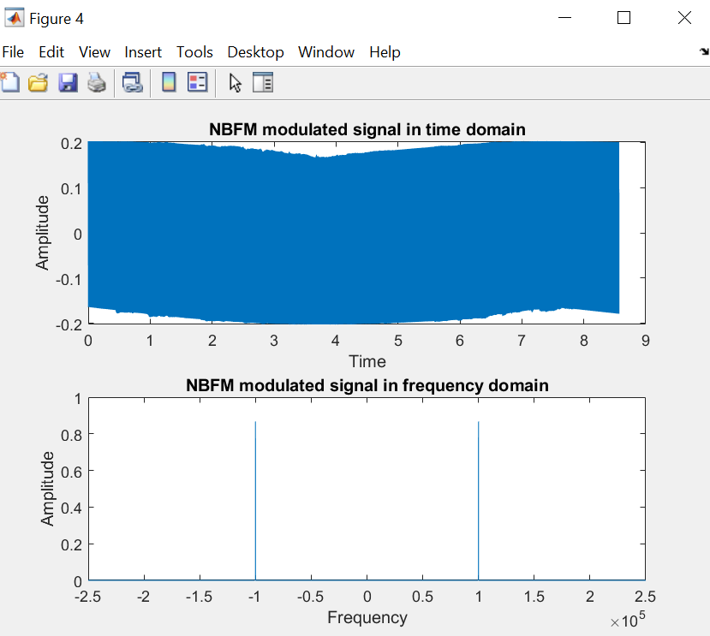

**\*What can you make out of the resulting plot?**

From the time domain, we could conclude that the signal resulted from the Narrow Band FM is similar to DSB-TC. Meanwhile, we can conclude, from the frequency domain, that the spectrum is mostly the carrier due to the small variations in the frequency.

**\*What is the condition we needed to achieve NBFM?**

Given that: U(t) = Ac* cos(2*pi*fc*t + (t)), where = 2*pi* kf * integration(message)

For the Narrow Band: 1 rad so,

And given that Beta = , where beta is the frequency deviation ratio or modulation index , is the frequency deviation Generally:

to obtain a Narrow Band: and the bandwidth is approximately 2fm

*Kf which is the frequency deviation constant or frequency sensitivity must be small to decrease the frequency deviation.

%Demodulation

Output_Signal_NBFM_diff = diff(NBFM_Signal)*Fs_NBFM;

Output_Signal_demod_time = abs(hilbert(Output_Signal_NBFM_diff));

Output_Signal_demod_time = Output_Signal_demod_time - abs(mean(Output_Signal_demod_time));

Output_Signal_demod_time_resampled = resample(Output_Signal_demod_time,fs,Fs_NBFM);

Output_Signal_demod_freq = fftshift(fft(Output_Signal_demod_time_resampled)./Fs_NBFM);

figure()

subplot(2,1,1);

time_demod =linspace(0, (length(Output_Signal_demod_time_resampled))/fs, length(Output_Signal_demod_time_resampled));

plot(time_demod,0.01*Output_Signal_demod_time_resampled);

ylim([-0.2 0.2]);

title('Demodulated signal in time domain');

xlabel('Time');

ylabel('Amplitude');

sound(Output_Signal_demod_time_resampled,fs);

subplot(2,1,2);

freq_demod = linspace(-fs/2, fs/2, length(Output_Signal_demod_freq));

plot(freq_demod,abs(Output_Signal_demod_freq));

title('Demodulated signal in frequency domain');

xlabel('Frequency');

ylabel('Amplitude');

